Name-Ujjawal Mandhani
Batch-F6
Enroll No.-9918103237
OSS Lab-Test

Question 1:

import pandas as pd
diamonds = pd.read_csv(
'https://raw.githubusercontent.com/mwaskom/seaborn-data/master/diamonds.csv')
print("Original Dataframe:")
print(diamonds.head())
print("\nSeries sorted by its values:")
print(diamonds.cut.value_counts().sort_values())
print("\nSeries sorted by its index:")
print(diamonds.cut.value_counts().sort_index())
diamonds["new_col"] = diamonds["price"] * diamonds["carat"]
diamonds.sort_values(by='new_col')
print(diamonds.head())

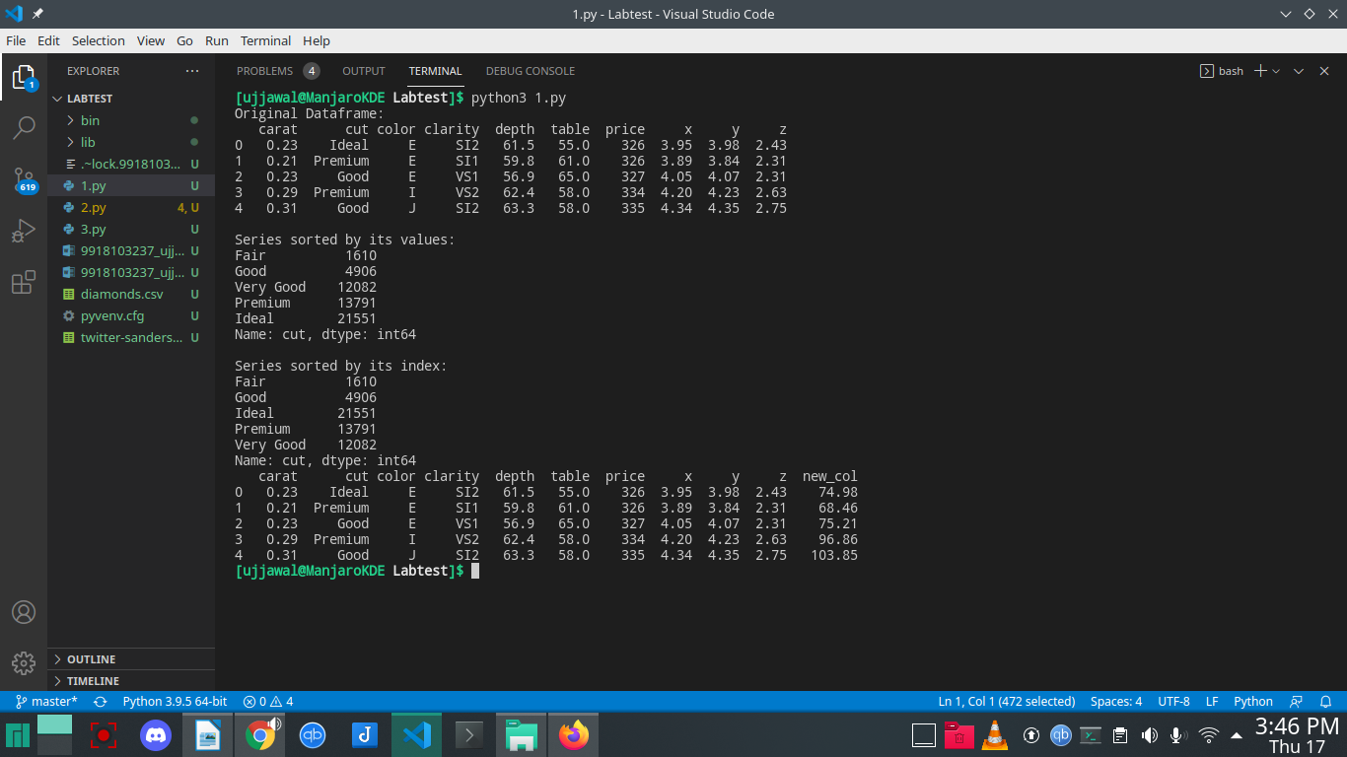
Question 2:

import pandas as pd
import numpy as np
import re
import string
from nltk.corpus import stopwords
from nltk.tokenize import word_tokenize
from sklearn.feature_extraction.text import TfidfVectorizer
from sklearn.model_selection import train_test_split
from nltk.stem import PorterStemmer
from nltk.stem import WordNetLemmatizer
from sklearn.metrics import accuracy_score
from sklearn.naive_bayes import MultinomialNB
from sklearn.linear_model import LogisticRegression
from sklearn.svm import SVC
stop_words = set(stopwords.words('english'))

def load_dataset(filename, cols):
dataset = pd.read_csv(filename, encoding='latin-1')
dataset.columns = cols
return dataset

def remove_unwanted_cols(dataset, cols):
for col in cols:
del dataset[col]
return dataset

def preprocess_tweet_text(tweet):
tweet.lower()
tweet = re.sub(r"http\S+|www\S+|https\S+", '', tweet, flags=re.MULTILINE)
tweet = re.sub(r'\@\w+|\#','', tweet)
tweet = tweet.translate(str.maketrans('', '', string.punctuation))
tweet_tokens = word_tokenize(tweet)
filtered_words = [w for w in tweet_tokens if not w in stop_words]
return " ".join(filtered_words)

def get_feature_vector(train_fit):
vector = TfidfVectorizer(sublinear_tf=True)
vector.fit(train_fit)
return vector

def int_to_string(sentiment):
if sentiment == 0:
return "Negative"
elif sentiment == 2:
return "Neutral"
else:
return "Positive"

dataset = load_dataset("data/training.csv", ['target', 't_id', 'created_at', 'query', 'user', 'text'])
n_dataset = remove_unwanted_cols(dataset, ['t_id', 'created_at', 'query', 'user'])
dataset.text = dataset['text'].apply(preprocess_tweet_text)
tf_vector = get_feature_vector(np.array(dataset.iloc[:, 1]).ravel())
X = tf_vector.transform(np.array(dataset.iloc[:, 1]).ravel())
y = np.array(dataset.iloc[:, 0]).ravel()
X_train, X_test, y_train, y_test = train_test_split(X, y, test_size=0.2, random_state=30)
NB_model = MultinomialNB()
NB_model.fit(X_train, y_train)
y_predict_nb = NB_model.predict(X_test)
print(accuracy_score(y_test, y_predict_nb))
LR_model = LogisticRegression(solver='lbfgs')
LR_model.fit(X_train, y_train)
y_predict_lr = LR_model.predict(X_test)
print(accuracy_score(y_test, y_predict_lr))
test_file_name = "trending_tweets/08-04-2020-1586291553-tweets.csv"
test_ds = load_dataset(test_file_name, ["t_id", "hashtag", "created_at", "user", "text"])
test_ds = remove_unwanted_cols(test_ds, ["t_id", "created_at", "user"])
test_ds.text = test_ds["text"].apply(preprocess_tweet_text)
test_feature = tf_vector.transform(np.array(test_ds.iloc[:, 1]).ravel())
test_prediction_lr = LR_model.predict(test_feature)
test_result_ds = pd.DataFrame({'hashtag': test_ds.hashtag, 'prediction':test_prediction_lr})
test_result = test_result_ds.groupby(['hashtag']).max().reset_index()
test_result.columns = ['heashtag', 'predictions']
test_result.predictions = test_result['predictions'].apply(int_to_string)
print(test_result)

